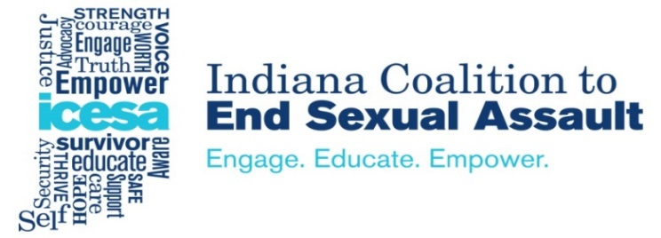

For more information contact:
Tracey Horth Krueger, CEO
317.989.8500
tracey@indianacesa.org

For Immediate Release

Indiana’s Statewide Sexual Assault Coalition Supports the Call for Attorney General Hill’s Resignation

The Indiana Coalition to End Sexual Assault (ICESA) wholeheartedly supports Governor Eric Holcomb, House Speaker Brian Bosma and Senator David Long in calling for the resignation of Attorney General Curtis Hill.

The four women, a state lawmaker and three legislative employees, bravely came forward to report the Attorney General’s offensive behavior. To be believed and supported by the Governor, Speaker of the House and the Senate Pro Tempore sends an incredibly important message that the state of Indiana and its elected leadership will not tolerate sexual harassment, coercion or assault and will foster an environment of safety and respect to all Hoosiers.

Attorney General Hill, in our opinion, has no choice but to resign immediately. Furthermore, he must apologize to the women directly involved, stop denying the allegations, own up to his actions, and apologize to citizens across Indiana. He was elected to serve as Indiana’s chief legal officer – his behavior on March 15, 2018 no longer allows him to hold the office with any integrity.

Sexual harassment, coercion and assault should never be tolerated; therefore, Attorney General Hill has no other choice but to do the right thing and resign.

We are deeply grateful to the women who made the decision to share their experiences. We stand with you.

-0-

